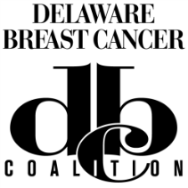
Delaware Breast Cancer Coalition (DBCC) Referral Form

DBCC’s Peer Mentor Support Program provides free one-on-one support and education to those newly diagnosed with breast cancer. DBCC Peer Mentors are trained breast cancer survivors who wish to reach out to help and support others with breast cancer. When diagnosed with breast cancer, it is often helpful to speak with someone who is a survivor and has been through a similar breast cancer experience. Additionally, DBCC staff can direct you to other community resources.
Please give us permission to have Lois Wilkinson from DBCC contact you about being matched with a Peer Mentor or to learn more about this and other DBCC programs.
Only the referral information on this form will be provided to DBCC
Name: _________________________________________________

Phone number: __________________________________________

Email address: __________________________________________

Best way to contact you: Telephone Email

Best time to contact you: Day Evening Specific Time:

By signing below I acknowledge voluntary referral to DBCC.

Signature Date

Provider please fax completed form to Lois Wilkinson at 302-672-7834

